Invitation to nominate for Governor Stirling Senior High
School Board 2024

From 2015, Governor Stirling Senior High School began operating as an Independent Public School (IPS) within the Government school system, an achievement that we are all proud of. The establishment of IPS requires the continuing service of a strong Board with a diverse skill set.

There are five (5) positions for PARENTS and two (2) positions in the category of COMMUNITY MEMBER.

I invite you to consider nominating for one of the PARENT member vacancies on the School Board. For 2024, there is ONE (1) vacancy for parent representatives. Appointment will be for a 2 two-year period from the first Board meeting of Term 2 (Monday 27 May 2024).

Board members play an important role in steering the school to make its vision a reality. During 2024, the Board will meet on the following dates, from 4.30pm in the Conference Room.

Term 1: Monday 18 March 2024
Term 2: Monday 27 May 2024 and Monday 24 June 2024
Term 3: Monday 26 August 2024
Term 4: Monday 28 October 2024 and Monday 25 November 2024

Governor Stirling SHS has a proud tradition of serving its school community since its establishment in 1956, and prior to that as Midland High School. The vision for the school is to work together with our community to develop, in our students, a life-long love of learning, and to give them the tools to thrive in their lives after school. We have high expectations of staff and students, cultivating excellence in teaching through evidence-based practice, a continuous cycle of improvement, and a positive, culturally inclusive learning environment. In support of this vision, being an IPS school gives us increased flexibility to develop our strong offering of specialist programs across a range of areas, including sports, the arts and the Gifted and Talented Selective Entrance Academic Program. For an overview of the range of activities currently on offer at Governor Stirling, I encourage you to visit our website, www.govo.wa.edu.au. Information on the Terms of Reference of the Board are also on the school website.

If you would like to nominate for the Board, please complete the attached nomination form and return it to Megan Smith at the front office or email to Megan.Smith33@education.wa.edu.au by no later than 4.00pm Friday 8 March 2024. An election will be held if there are more nominations than positions. Please be advised that if elected you will be required to undertake a National Police History Check through the Department of Education at no cost to you.

If you have any questions regarding the role on the Board, please do not hesitate to contact me on 6274 0300.

Yours sincerely
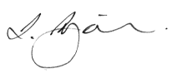
Leo Surjan
Principal

1 March 2024
GOVERNOR STIRLING SENIOR HIGH SCHOOL
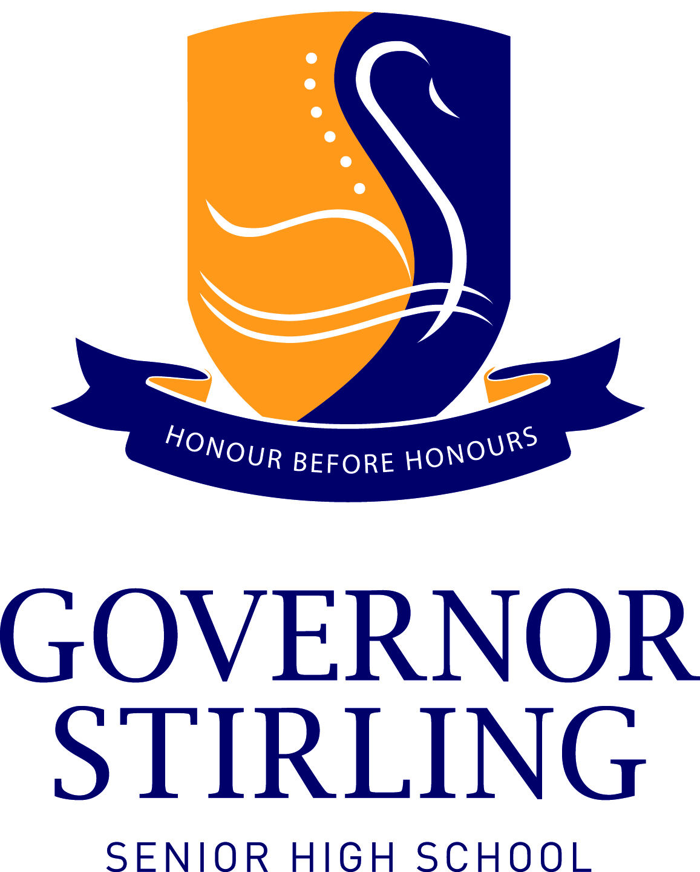
SCHOOL BOARD NOMINATION FORM 2024
PARENT REPRESENTATIVE
There is ONE (1) vacancy for 2024. The normal term of parent representatives is two (2) years. The period commences from Monday 27 May 2024.

To: The Principal
I, _______________________________________, wish to nominate for the Governor Stirling
( Print Name)
Senior High School Board.

NOMINEE SIGNATURE: ___________________________________________
Date: ____________________________
Email address of Nominee ____________________________________________
Mobile number of Nominee ____________________________________________
Briefly answer the following questions (50 to 70 words to be placed on the school website for voting process):
What contribution would you make to Governor Stirling Senior High School through the Board?

What skills do you bring?

Relevant experience:

- Please complete (hard copy or electronic, electronic preferred) and email the completed Nomination Form to Megan Smith (Megan.Smith33@education.wa.edu.au) at the school reception no later than 4.00pm Friday 8 March 2024.
- In the email, please include the subject heading “School Board Nomination 2024 of <your NAME>”.

